### **Exception**

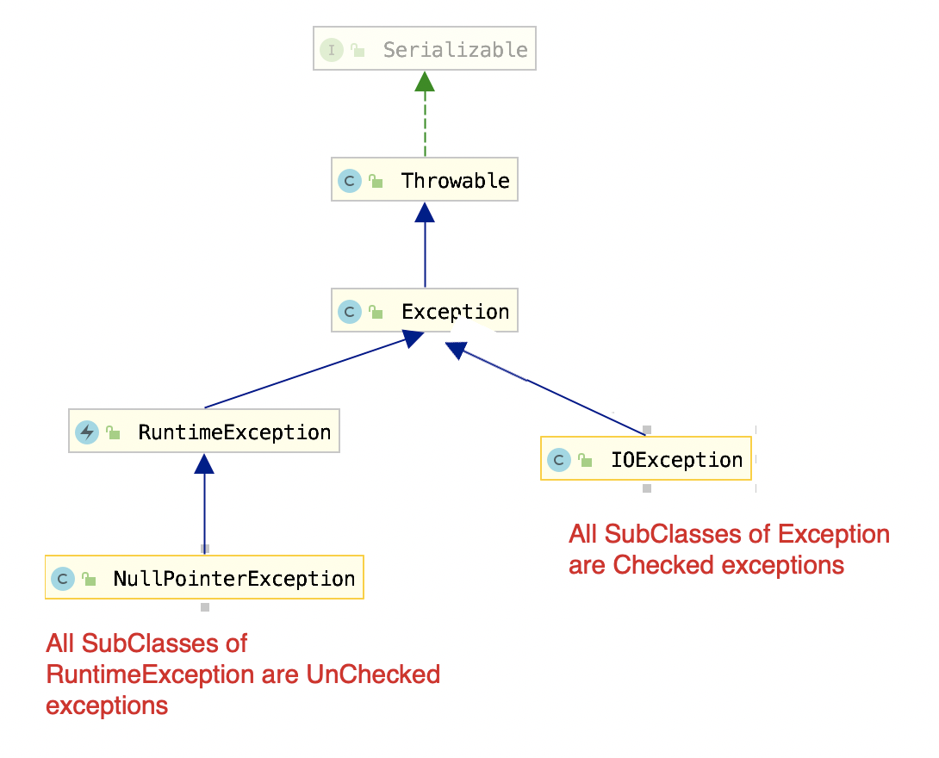

****Checked Exception:**** Has to be try-catched or decleared using throws keyword on method.

****UnChecked Exception****: Don't need to be try-catched or decleared.

****Throwable**** is the parent class of all exceptions and errors.

Exception Handling

class AntraUserNotFoundException extends Exception { // this is an checked exception

}

class Test {

public void doSomething() throws AntraUserNotFoundException { // declear. otherwise error in compilation.

throw new AntraUserNotFoundException();

}

public void doSomethingElse() {

try {

doSomething(); // because doSomething throws, so here to catch. otherwise error.

}catch(AntraUserNotFoundException ex) {}

}}

// If we create an unchecked exception, then no need to declear or try-catchclass AntraUserNotFoundExeption extends RuntimeException{} // this is unchecked exception

public void doSomething(){

throw new AntraUserNotFoundException();}

##### **Try-catch-finally**

Multiple catch blocks can be put after a try block.

Finally block is optional.

Try-Finally block is also valid. No catch block.

https://www.youtube.com/watch?v=dq8A1PVQDRE